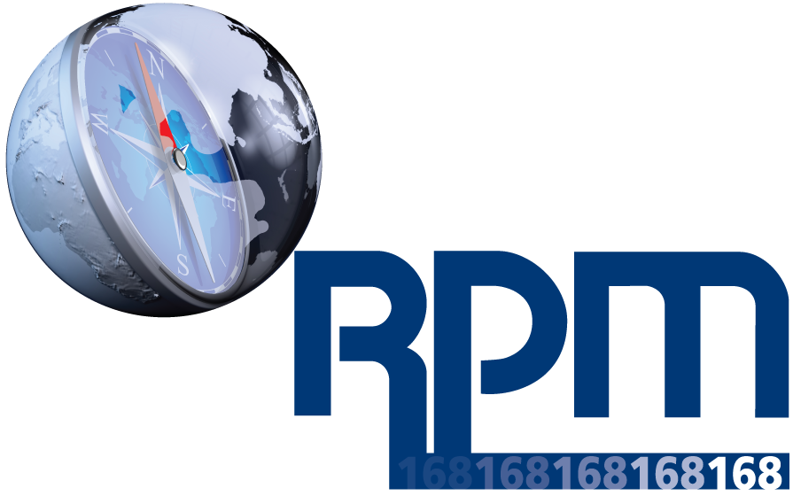
Employee Training Participation and Acknowledgment on RPM International Inc.’s RPM’s V&E’s 168

By signing below I acknowledge that on __________________, I received training and information on RPM’s V&E’s 168. The training session was conducted by ___________________________ at __________________________ facility located in ____________________.

If I have any questions or do not understand any part of it I will contact RPM’s Director of Global Compliance within fourteen (14) days of this training to seek clarification. Accordingly, I agree to comply with all instructions, policies, guidelines and procedures outlined in this training and discussed during today’s training. I understand that I am responsible for abiding by the Values & Expectations of 168 and for ensuring that all operations under my control comply with all applicable laws, rules, regulations and company policies.

 | LEGIBLY PRINT YOUR NAME | TITLE | TIME IN | TIME OUT | SIGNATURE
1
2
3
4
5
6
7
8
9
10
11
12
13
14
15
16
17
18
19
20
21
22
23
24
25
26
27
28
29
30
31
32
33
34
35
36
37
38
39
40
41
42
43
44
45
46
47
48
49
50
51
52
53
54
55
56
57
58
59
60
61
62
63
64

